SERVICENOW MICRO-PROJECT DOCUMENTATION
Implement Client Script & UI Policy (Incident)
ServiceNow Incident Management Configuration

Project Platform | ServiceNow
TEAM ID | SWTID-2026-8886
Application / Table | Incident [incident]
Project Type | SkillWallet Micro-Project
Focus | Client Scripts, UI Policies and Incident validation
Status | Implemented and functionally tested

1. Title
Implement Client Script & UI Policy (Incident)

2. Aim
To configure Client Scripts and a UI Policy on the ServiceNow Incident form to automatically control field behavior, validate incident data before submission, and prevent inappropriate list-based updates.

3. Objectives
- Create a UI Policy for High Impact incidents.
- Make Assignment group mandatory when Impact is High.
- Make Urgency read-only when Impact is High.
- Automatically set Urgency to High when Impact changes to High.
- Prevent saving a High Impact incident when Assigned to is empty.
- Prevent State changes through list editing while allowing changes from the Incident form.
- Verify the Reverse if false behavior when the Impact condition is no longer true.

4. Software / Tools Required
- ServiceNow developer instance
- Incident application / Incident [incident] table
- System Definition → Client Scripts
- System UI → UI Policies / UI Policy Actions
- Web browser

5. Theory
A Client Script is a JavaScript-based client-side configuration used to control form behavior in ServiceNow. Depending on its type, it can run when a form loads, when a field changes, before a record is submitted, or when a list cell is edited.
A UI Policy dynamically controls form fields according to a condition. UI Policy Actions can make a field mandatory, read-only, or visible. The Reverse if false option removes the policy action when the condition is no longer satisfied.

6. Project Configuration Summary
Configuration | Type | Trigger / Condition | Affected Field | Purpose
High Impact Control | UI Policy | Impact = 1 - High | Assignment group | Makes Assignment group mandatory for high-impact incidents.
High Impact Control | UI Policy Action | Impact = 1 - High | Urgency | Makes Urgency read-only under High Impact.
Auto set urgency for high impact | onChange Client Script | Impact changes to High | Urgency | Automatically sets Urgency to High and displays an info message.
Prevent save if Assigned To missing | onSubmit Client Script | Impact = High AND Assigned to empty | Assigned to | Stops invalid submission and displays an error.
Prevent state change via list edit | onCellEdit Client Script | State edited from list | State | Blocks list-based State editing and instructs the user to open the Incident.

7. Procedure / Implementation

7.1 Create UI Policy – High Impact Control
- Navigate to All → System UI / UI Policies and create a new UI Policy for the Incident table.
- Name: High Impact Control.
- Condition: Impact is 1 - High.
- Enable the policy.
- Enable Reverse if false so the field restrictions are removed when Impact is changed away from High.
UI Policy Action – Assignment group:
- Field: Assignment group
- Mandatory: True
- Visible: Leave alone
- Read only: False
UI Policy Action – Urgency:
- Field: Urgency
- Read only: True
- Mandatory/Visible: Leave as configured

7.2 Create onChange Client Script – Auto Set Urgency
Name: Auto set urgency for high impact
Type: onChange | Table: Incident | Field: Impact | Active: True
function onChange(control, oldValue, newValue, isLoading) {
if (isLoading || newValue == '') {
return;
}
if (newValue == '1') {
g_form.setValue('urgency', '1');
g_form.addInfoMessage('Urgency set to High for High impact incident.');
}
}

7.3 Create onSubmit Client Script – Save Validation
Name: Prevent save if Assigned To missing
Type: onSubmit | Table: Incident | Active: True
function onSubmit() {
if (g_form.getValue('impact') == '1' &&
g_form.getValue('assigned_to') == '') {
g_form.showErrorBox(
'assigned_to',
'Assigned To is mandatory for High impact incidents.'
);
return false;
}
return true;
}

7.4 Create onCellEdit Client Script – State Protection
Name: Prevent state change via list edit
Type: onCellEdit | Table: Incident | Field: State | Active: True
function onCellEdit(sysIDs, table, oldValues, newValue, callback) {
alert('State cannot be updated using list editing. Please open the Incident.');
callback(false);
}

8. Testing and Verification
Test Case | Action | Expected Result | Observed Result
TC-01 High Impact UI Policy | Set Impact = High | Assignment group becomes mandatory and Urgency becomes read-only. | Passed
TC-02 Automatic Urgency | Change Impact to High | Urgency is set to High and an information message is displayed. | Passed
TC-03 Invalid submission | Impact = High; Assigned to empty; Submit/Update | Save is blocked and validation error is shown. | Passed / configured for validation
TC-04 List State edit | Edit State directly from Incident list | Alert appears and the list edit is cancelled. | Passed
TC-05 Form State edit | Open Incident, change State, Update | State change is saved from the form. | Passed
TC-06 Reverse condition | Change Impact from High to Medium | High-impact restrictions are reversed; Urgency becomes editable. | Passed

9. Test Scenarios
New Incident: Create/open an Incident and verify that the form accepts the configured field behavior. Select High Impact and verify the UI Policy and onChange behavior.
In Progress: Open an Incident, change State to In Progress from the form, and update the record. The change should be accepted because the onCellEdit restriction applies only to list editing.
Resolved: Open an Incident and move it to Resolved after providing any fields required by the instance. Verify that the record can be updated through the form.

10. Expected Behavior Matrix
Condition / Action | Assignment group | Urgency | Save / State
Impact = High | Mandatory | Read-only; High | Assigned to required on submit
Impact = Medium | High-impact mandatory rule reversed | Editable | Normal save behavior
State edited from list | — | — | Edit blocked
State changed from opened form | — | — | Update allowed

11. Result
The ServiceNow Incident configuration was implemented successfully using a UI Policy and Client Scripts. High-impact incidents enforce the required field behavior, Urgency is automatically set to High, invalid submissions are prevented when Assigned to is missing, and direct State changes through list editing are blocked. Form-based State changes remain available, and the Reverse if false behavior was verified by changing Impact from High to Medium.

12. Conclusion
The project demonstrates how ServiceNow UI Policies and Client Scripts can work together to improve form usability, automate field values, enforce validation, and protect Incident data from inappropriate updates. The implemented configurations were tested against high-impact, normal-impact, list-editing, and form-update scenarios and behaved as intended.

13. Documentation Checklist
☐ UI Policy purpose, condition, and affected fields documented.
☐ UI Policy Actions documented.
☐ onChange Client Script purpose and script documented.
☐ onSubmit validation and expected error behavior documented.
☐ onCellEdit restriction and expected alert documented.
☐ Reverse if false behavior documented and tested.
☐ New, In Progress, and Resolved scenarios included for final verification.
☐ Screenshots can be inserted in the evidence section before submission.

14. Screenshot Evidence – Insert Here

- Screenshot 1 – High Impact UI Policy / Assignment group action:
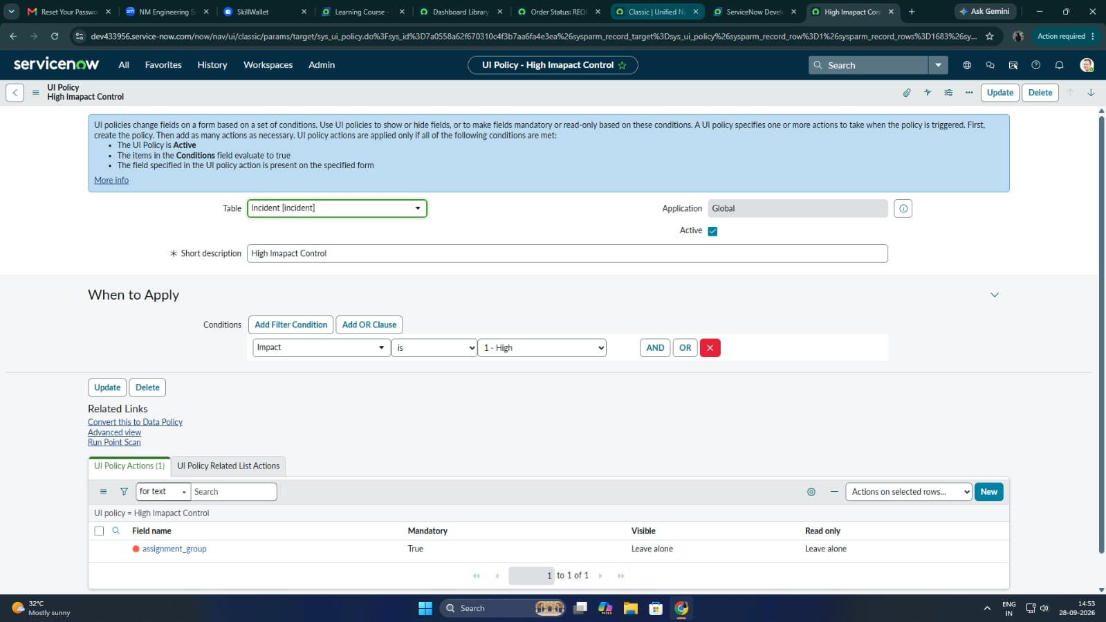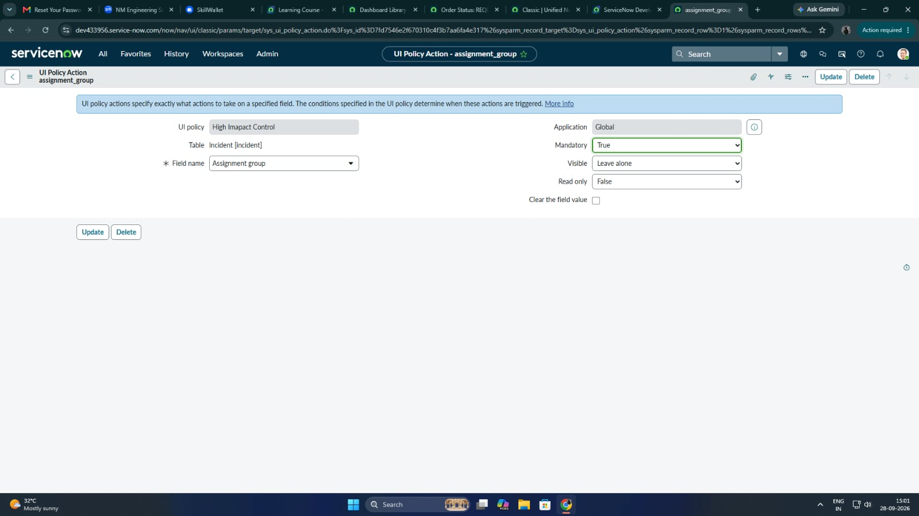

- Screenshot 2 – Urgency read-only under High Impact

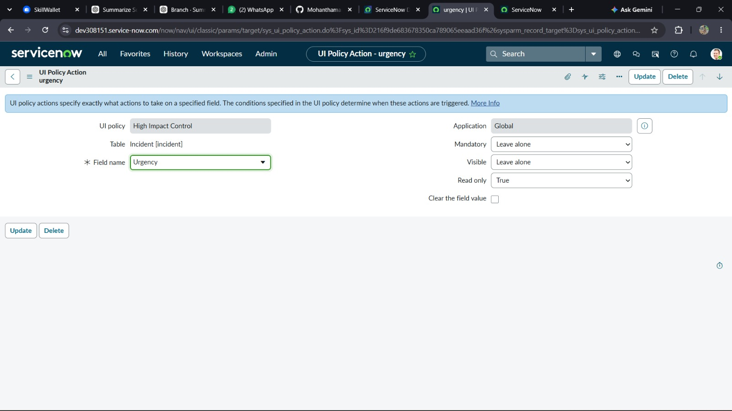

- Screenshot 3 – onChange information message and Urgency = High

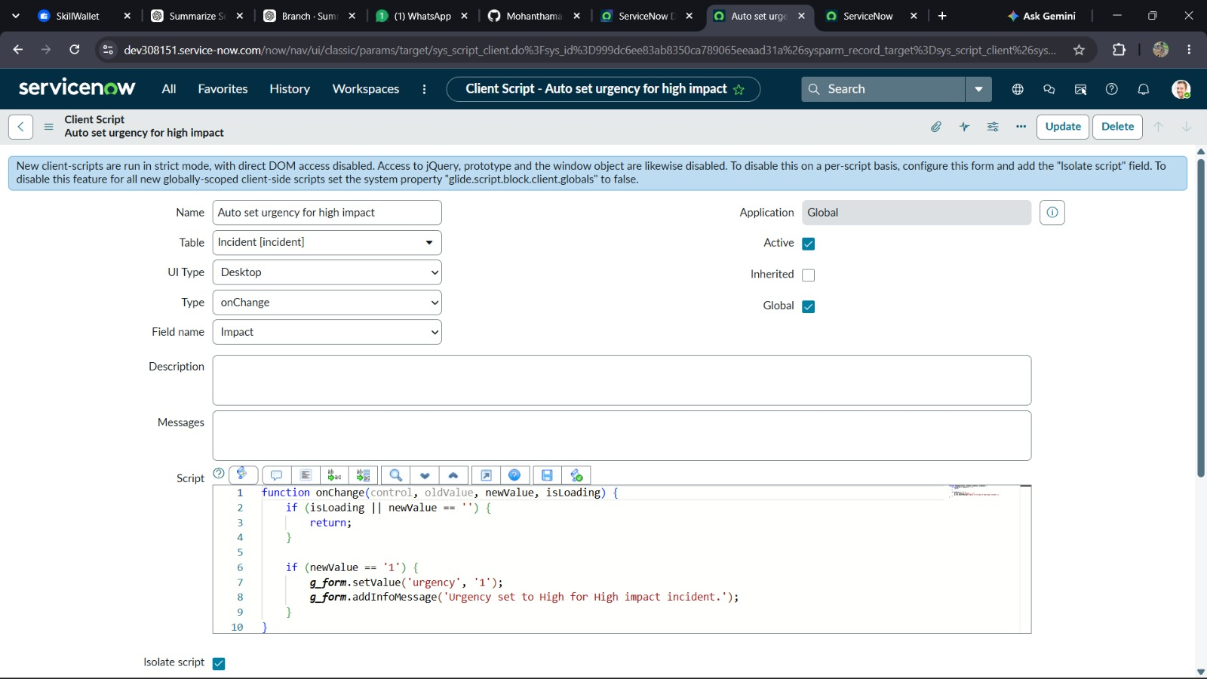

- Screenshot 4 – onSubmit validation error

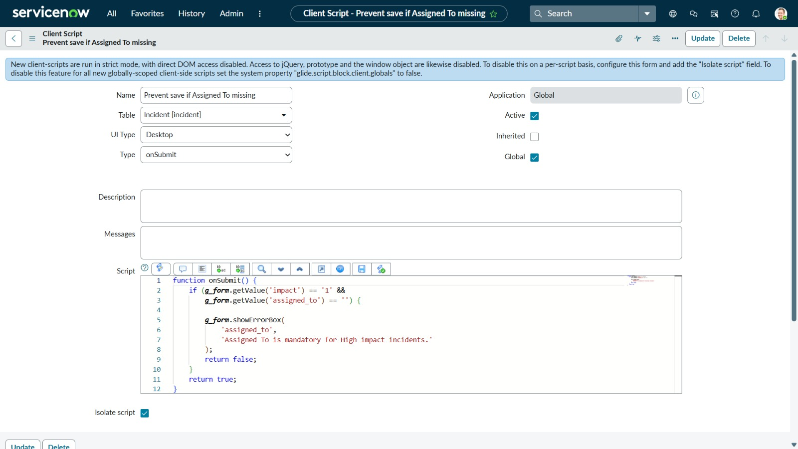

- Screenshot 5 – onCellEdit State alert

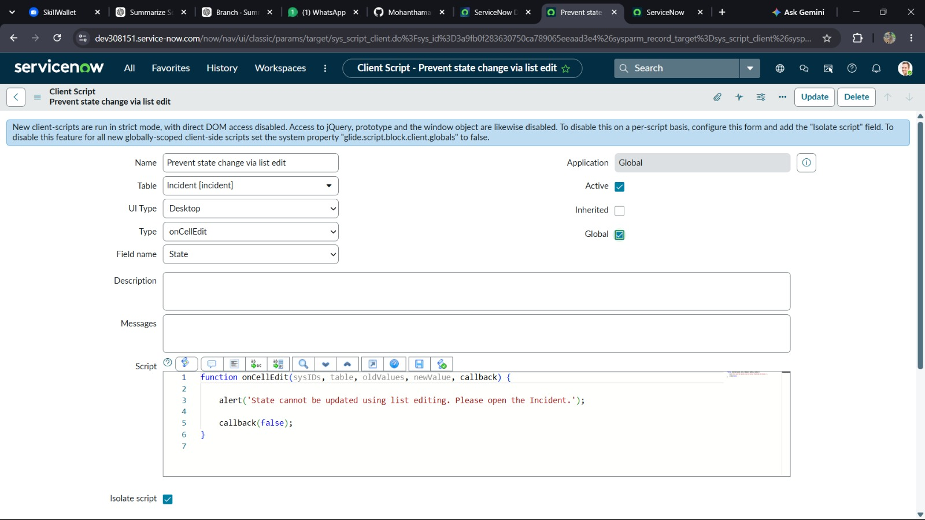

- Screenshot 6 – Testing the UI Policy

6.1-

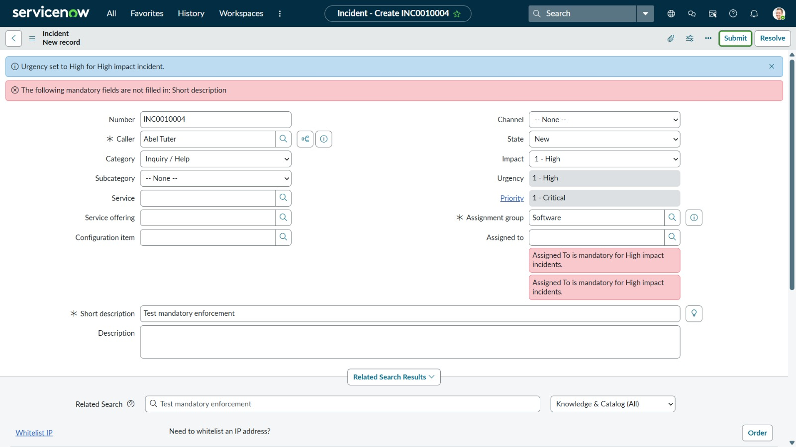

6.2-

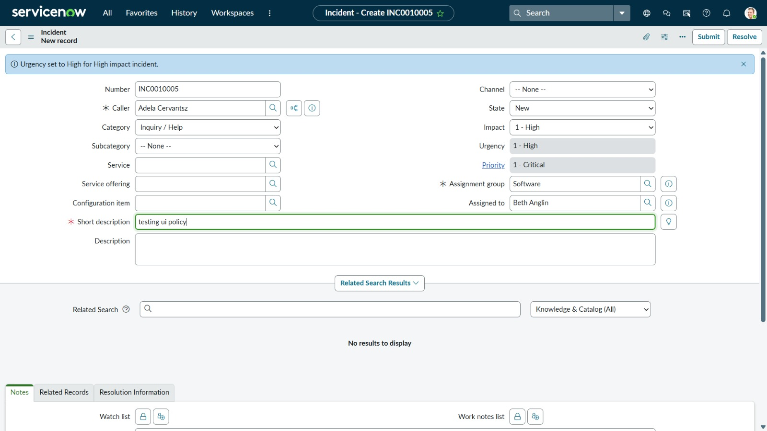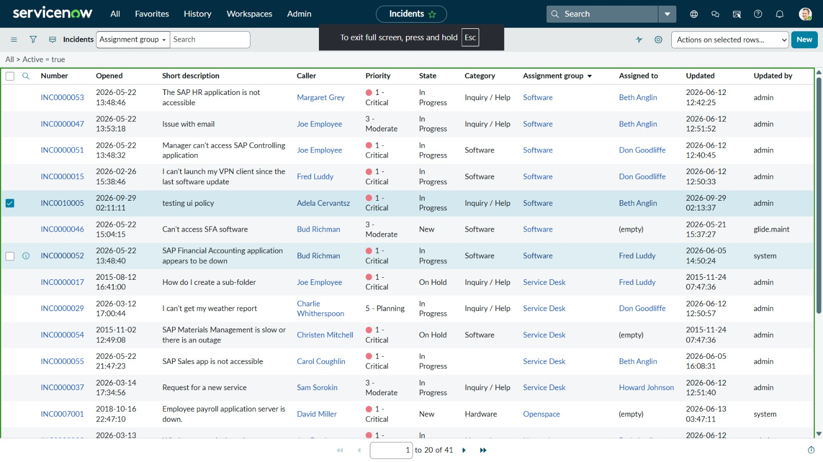
6.3-

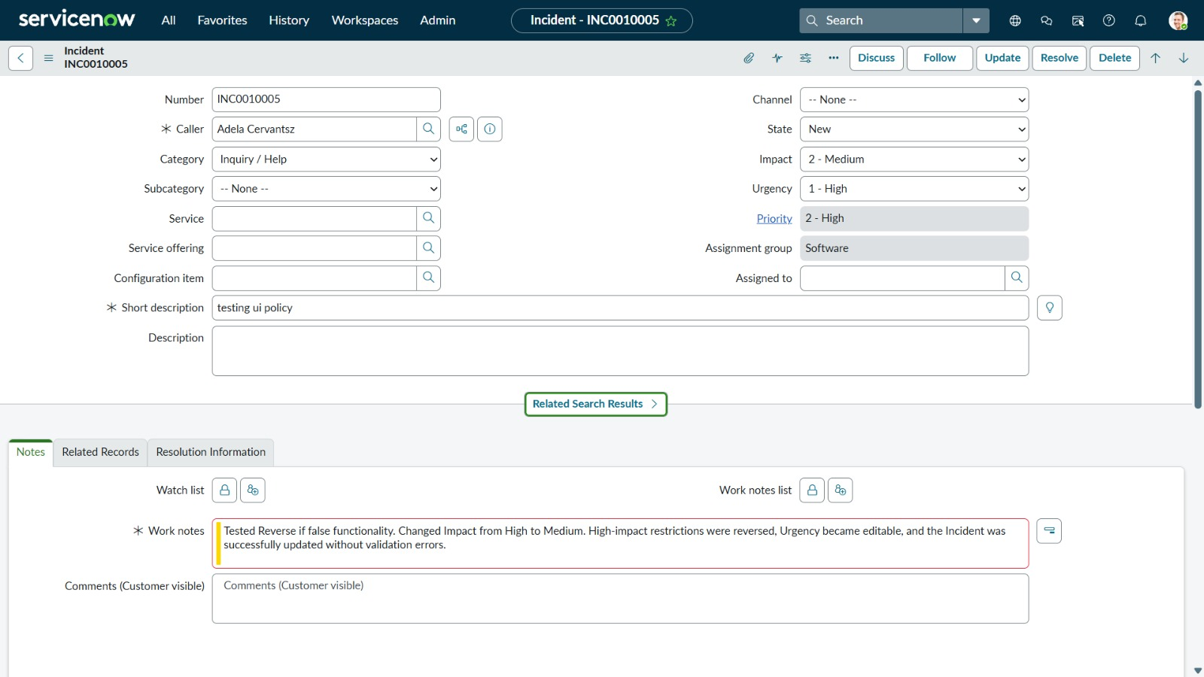

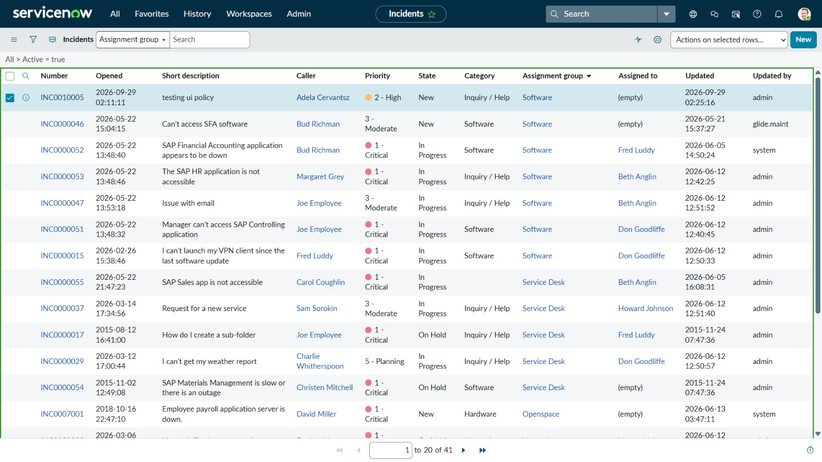

6.4-
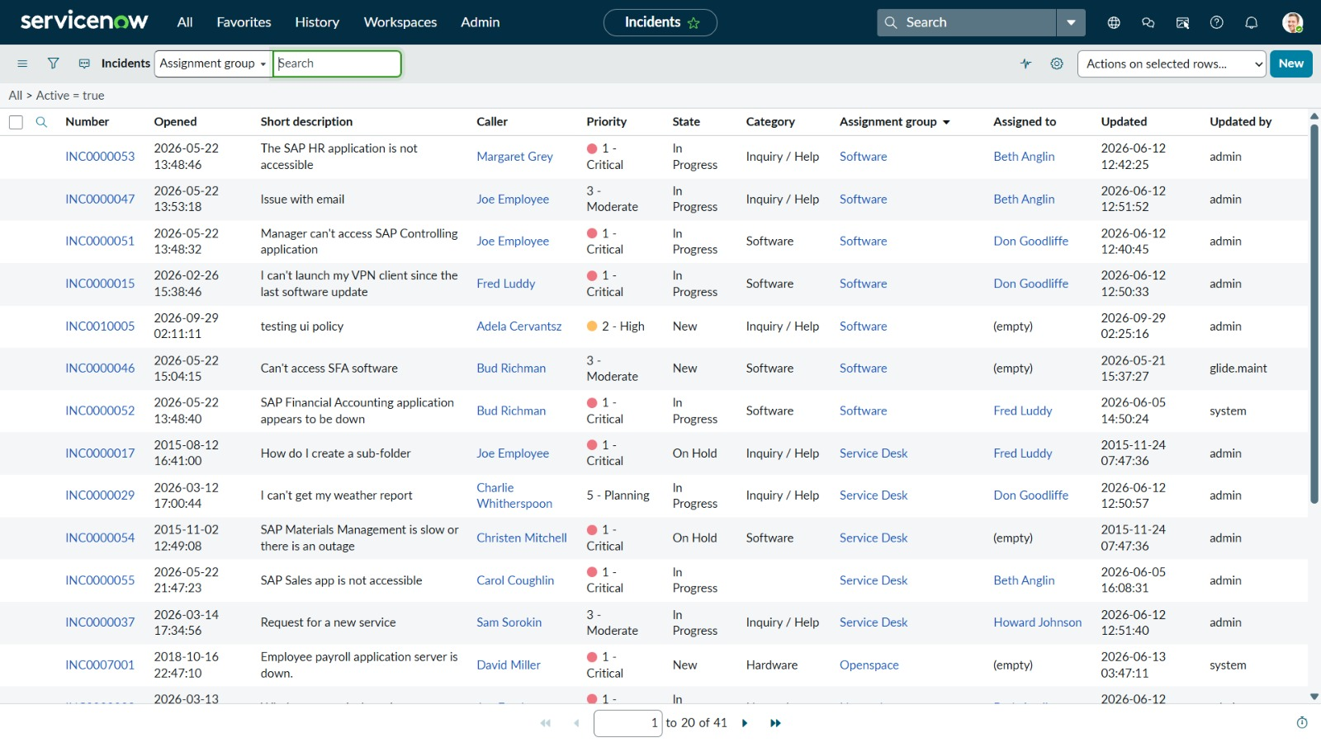

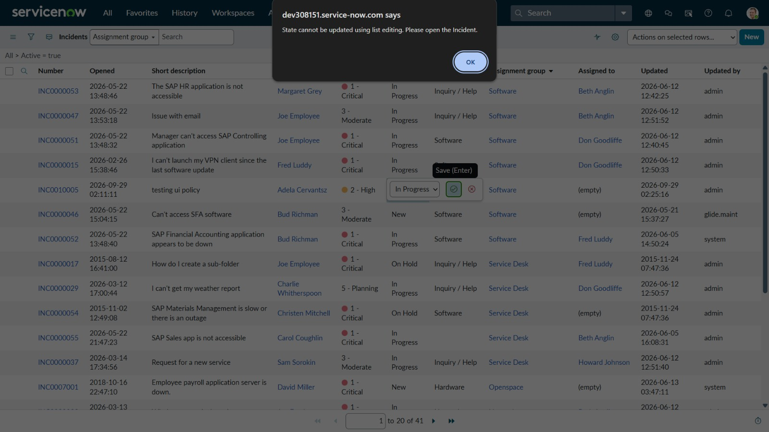

6.5-

